**Video-lessons students**

**INFOWhat** is the only computer school that gives its students the ability to practice on the **INFOWhat-ates** software[1] program.

**INFOWhat-ates**software program works exactly as all other international certification bodies’ programs work and helps the students get familiar with the examination environment.

The **students** of **INFOWhat** during the examination are not caught by surprise but are examined in a familiar environment.

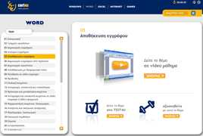

1. video-lessons